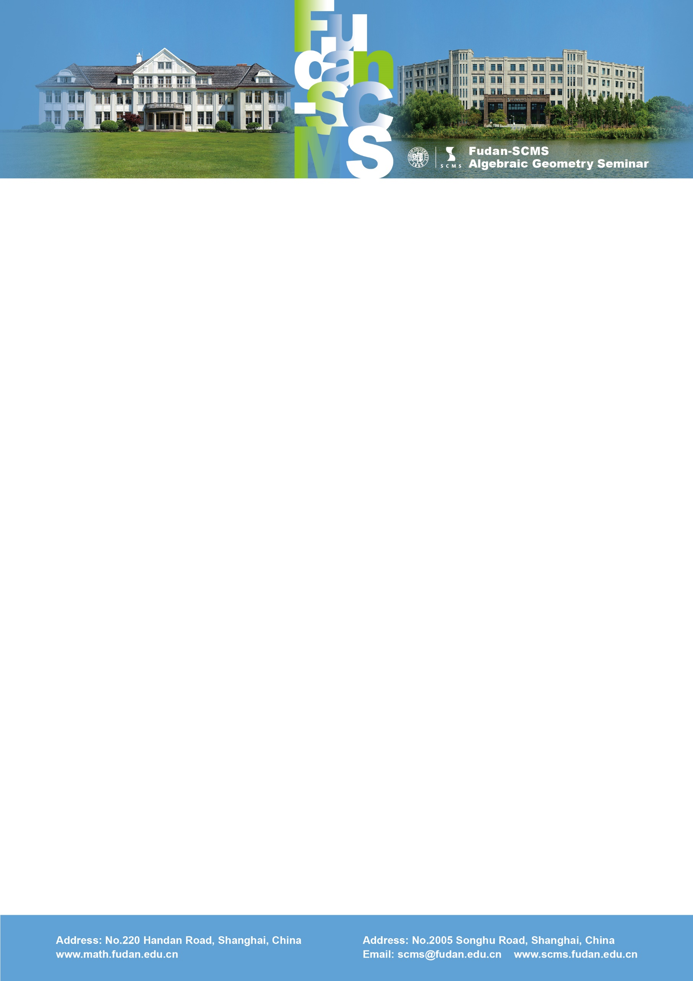

Fudan-SCMS Algebraic Geometry Seminar
Zoom Meeting Seminar
Lecture :
Uniqueness of the minimizer for the normalized volume function
Speaker: Ziquan Zhuang (MIT)
Time：Thu, Oct 15, BJS 21:00-22:00, EST 09:00-10:00, GMT 13:00-14:00
Zoom Meeting Id: 699 490 44388
Password: 647076
Abstract: Motivated by the study of K-stability of Fano varieties, Chi Li introduced the normalized volume function on the space of valuations over a klt singularity. He conjectured that the minimizer of this function is unique up to rescaling. In this talk, I'll define the notion of K-semistable valuations and discuss how it leads to a proof of Li's conjecture. Based on joint work with Chenyang Xu.

