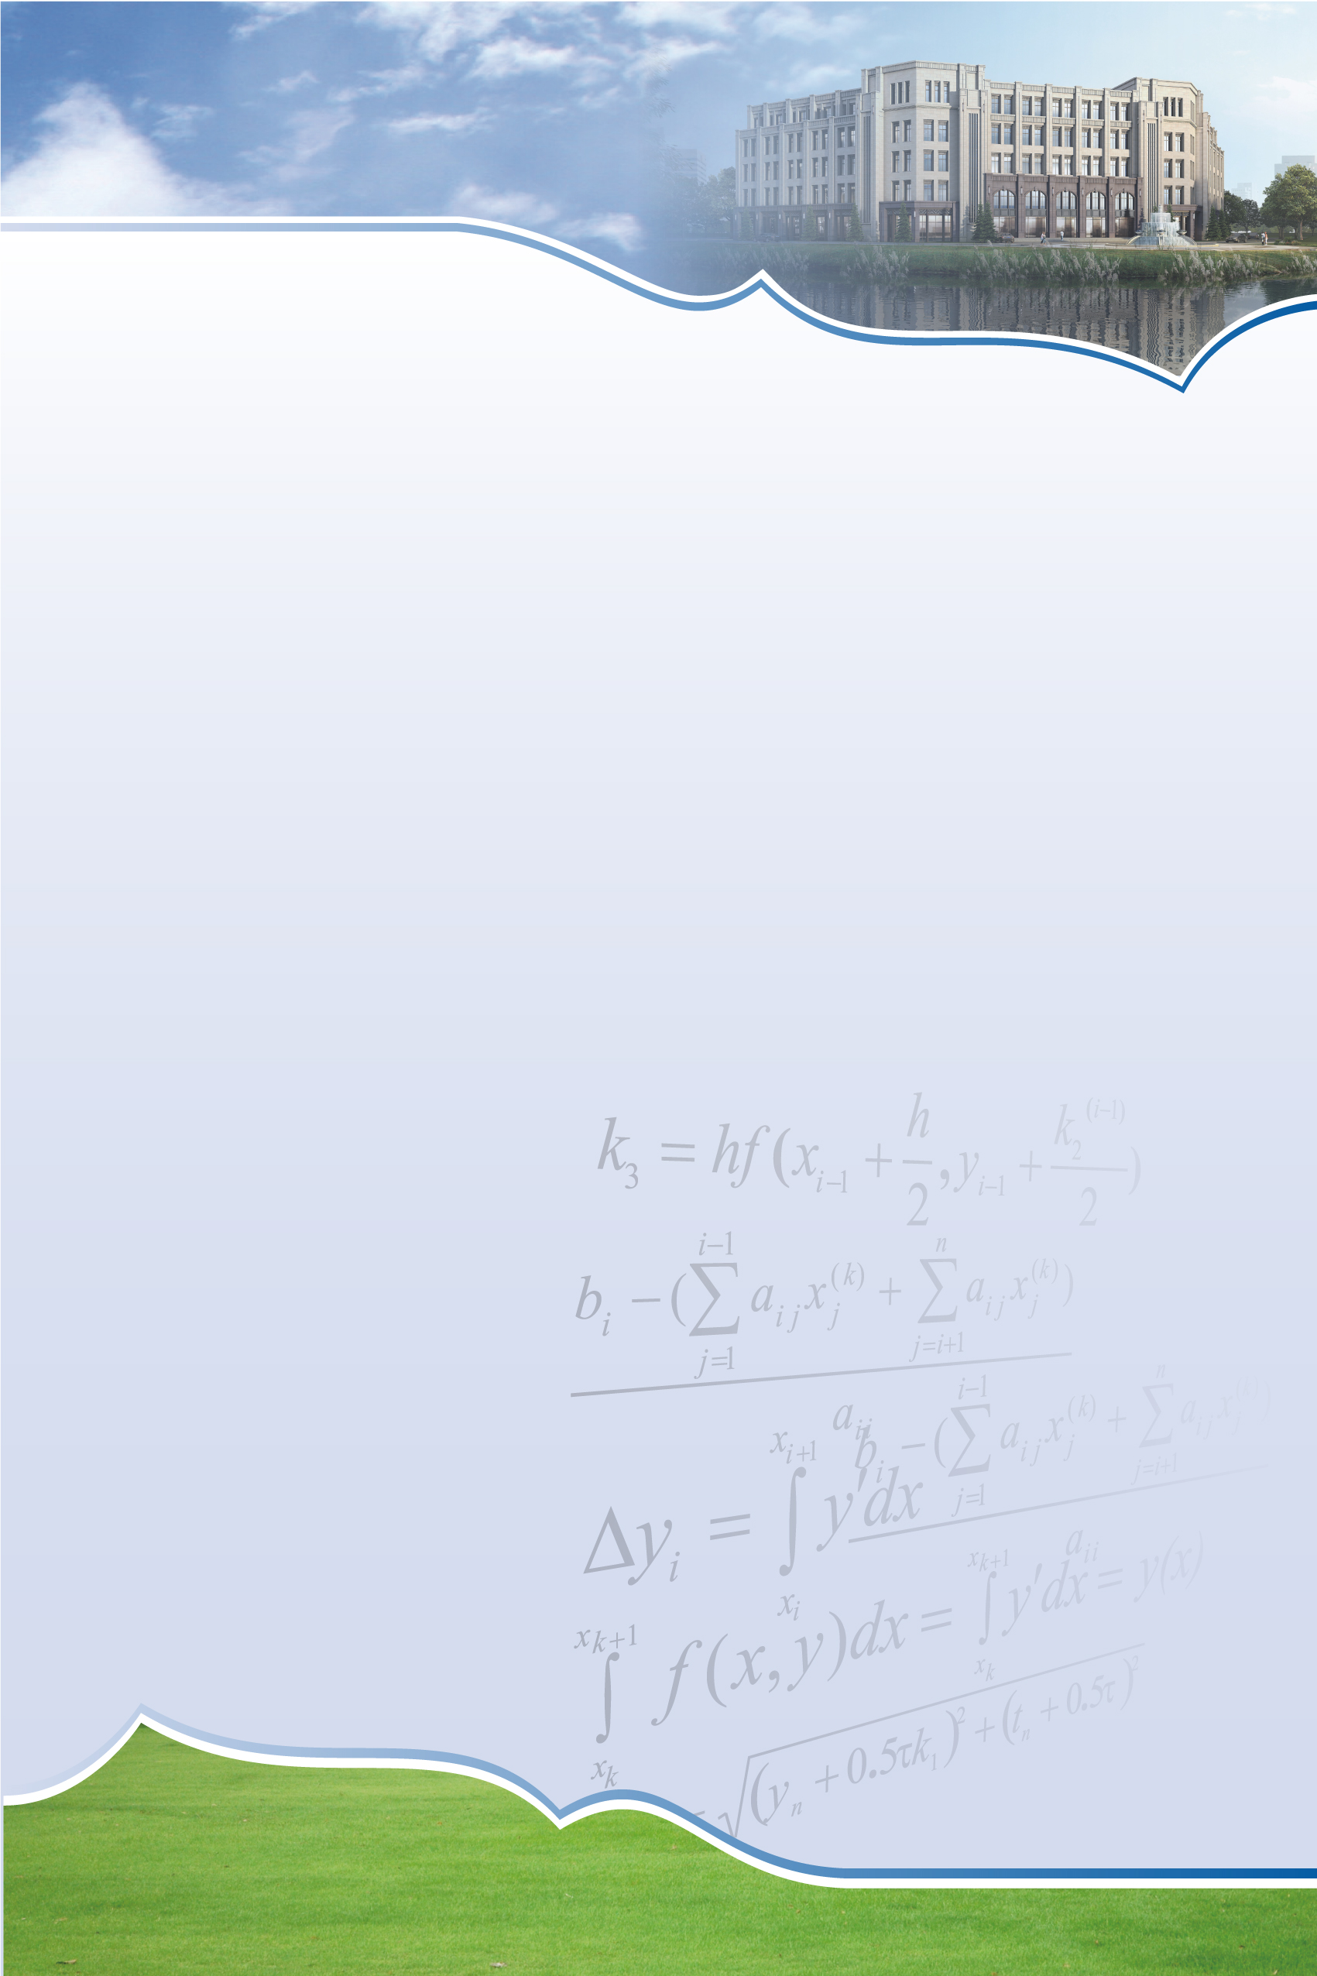
SCMS Seminar

Validity of Steady Prandtl Expansion
Speaker: Yan Guo
Brown University
Lecture
Time: 10:00-10:50,Wednesday, July 24, 2019
Venue: Room 102, Shanghai Center for Mathematical Sciences
Abstract: In a joint work with Sameer Iyer, the validity of steady Prandtl layer expansion is established in a channel. Our result covers the celebrated Blasius boundary layer profile, which is based on uniform quotient estimates for the derivative Navier-Stokes equations, as well as a positivity estimate at the flow entrance.

Shanghai Center for Mathematical Sciences
2005 Songhu Road,Yangpu District, Shanghai, China
Tel: 31243880 Fax: 31244000 Postcode: 200433 Email: scms@fudan.edu.cn

