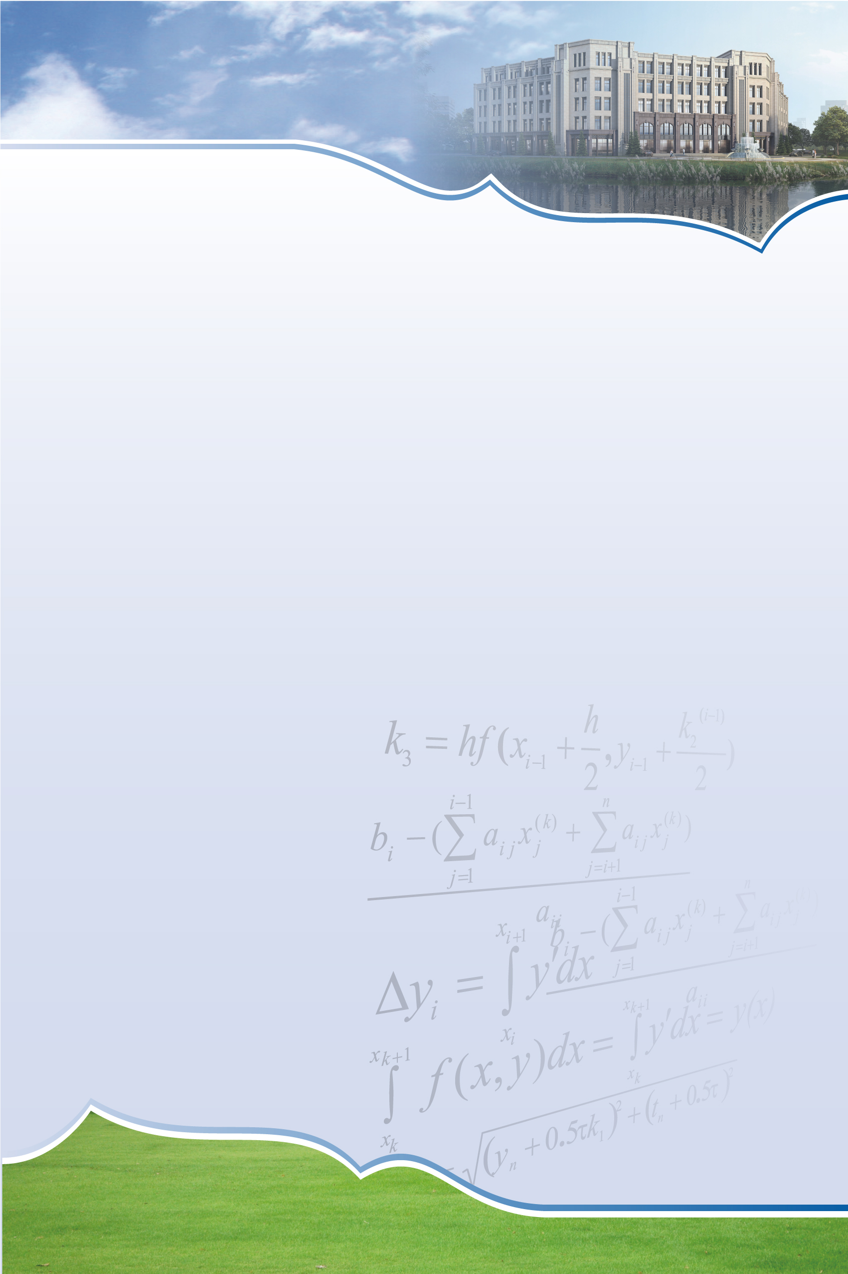
SCMS Seminar

Some inequalities and rigidity on gradient shrinking Ricci solitons

Speaker: Jianyu Ou
Shanghai Center for Mathematical Sciences

Time: 15:30-16:00, Wednesday, October 16th, 2019
Venue: Room 106, SCMS

Abstract:
In this talk I will show a rigidity theorem for gradient shrinking Ricci solitons supporting the Heisenberg-Pauli-Weyl uncertainty principle with the sharp constant in R^n. I will give a brief introduction to Ricci soliton, and then talk about the obtained result. Finally, I will talk about my future works to study gradient shrinking Ricci solitons.

Shanghai Center for Mathematical Sciences
No.2005 Songhu Road, Shanghai, China
Tel: 31243880 Fax: 31244000 Postcode: 200438 Email: scms@fudan.edu.cn

