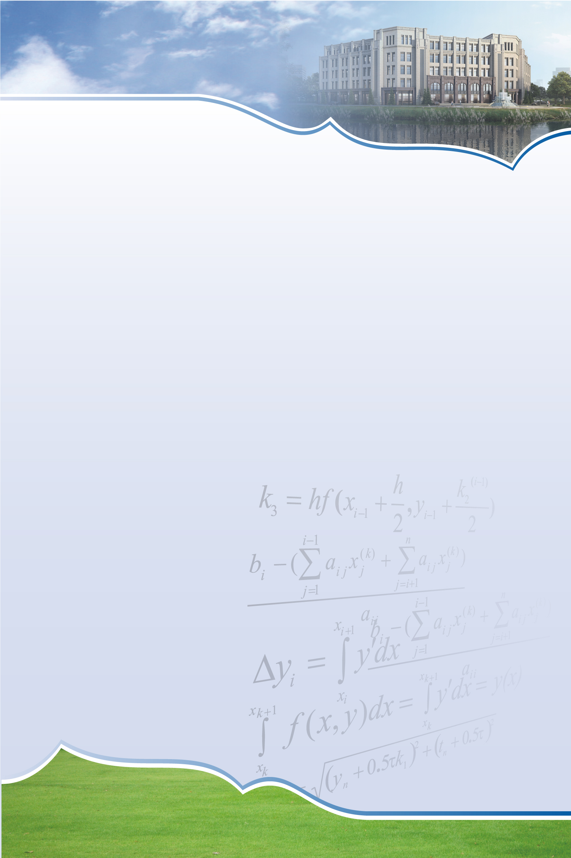
SCMS Seminar

Invariant Submanifolds of Kahler Manifold
Speaker: Jun Sun
Wuhan University

Lecture
Time: 14:00-16:00, Thursday, Oct. 31, 2019
Venue: Room 110, Shanghai Center for Mathematical Sciences
Abstract: This talk consists of two parts related to the invariant submanifold of Kahler manifold. The first part is about the variational characterizations of holomorphic submanifolds in Kahler manifold. This is based on joint work with Claudio Arezzo at ICTP. We will also mention recent progess on variational characterizations of invariant submanifold in Sasaki manifold. The second part is about two approaches to the existence of holomorphic curves in Kahler surface. One is the symplectic mean curvature flow and the other is the deformtaion of symplectic critical surfaces. This is based on joint work with Xiaoli Han and Jiayu Li.

Shanghai Center for Mathematical Sciences
No.2005 Songhu Road, Shanghai, China
Tel: 021-31243880 Fax: 021- 31244000 Postcode: 200438 Email: scms@fudan.edu.cn

