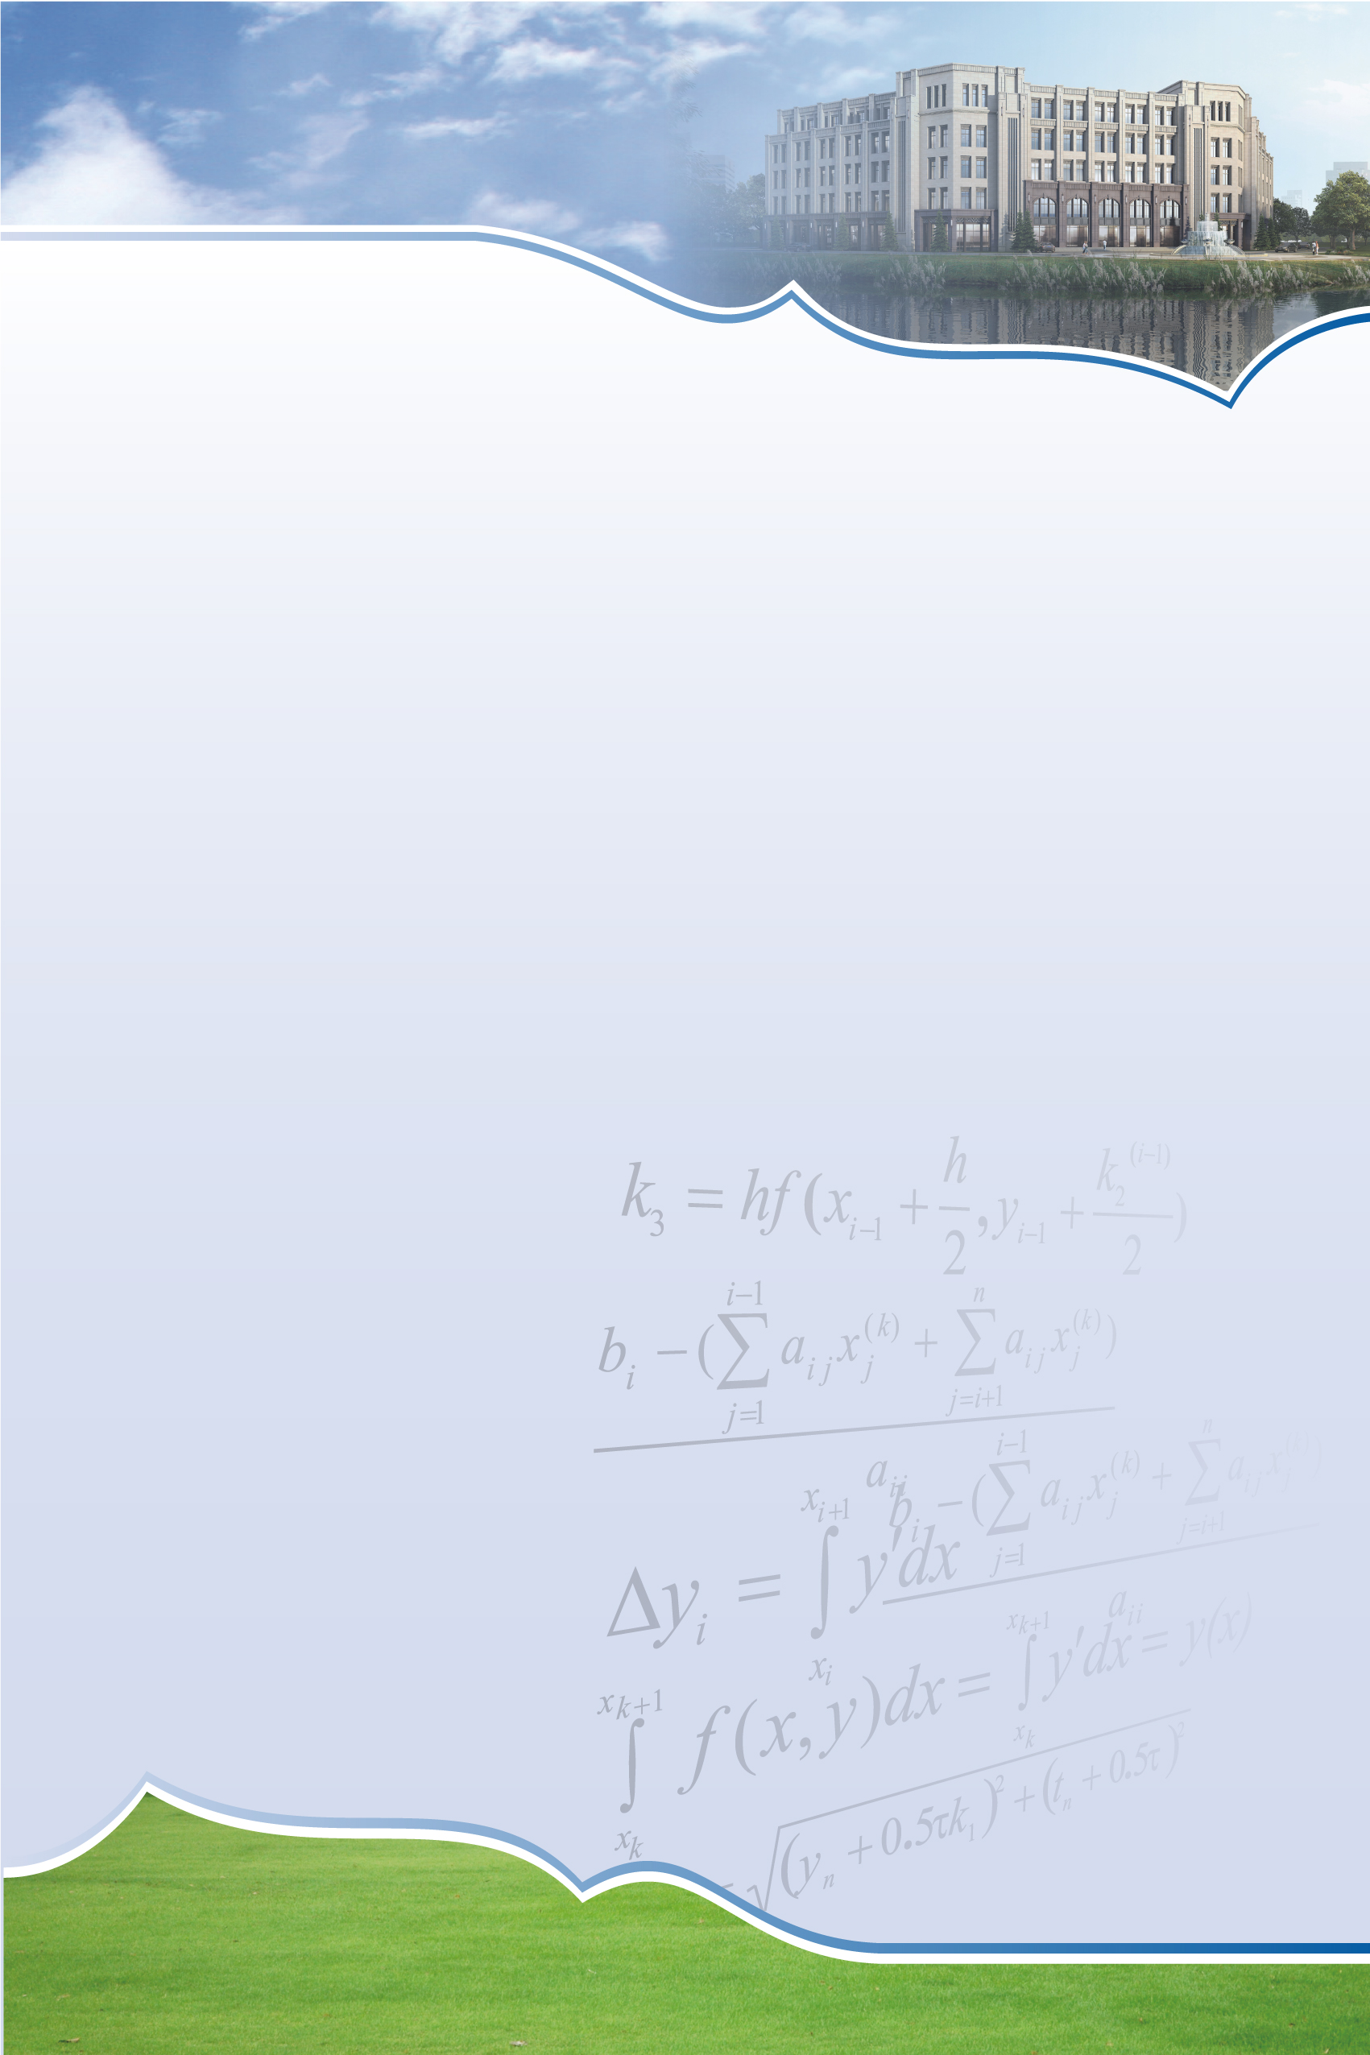
SCMS Seminar

On some fully nonlinear PDEs
Speaker: Dekai Zhang
Shanghai Center for Mathematical Sciences

Time: 15:00-15:30, Wednesday, October 16th, 2019
Venue: Room 106, SCMS

Abstract:
In this talk, we will talk about some fully nonlinear elliptic PDEs with geometric backgrounds. Some existence and regularity results of these equations will be reported.

Shanghai Center for Mathematical Sciences
22F East Guanghua Tower, No.220 Handan Road, Shanghai, China
Tel: 55665643 Fax: 65642190 Postcode: 200433 Email: scms@fudan.edu.cn

