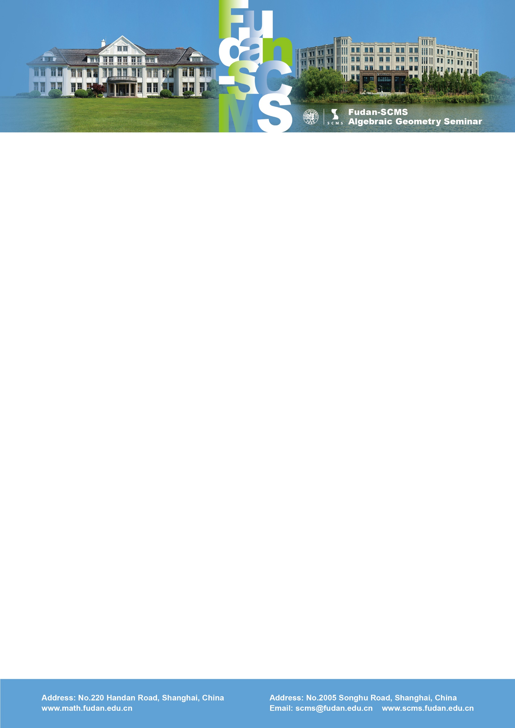

Fudan-SCMS Algebraic Geometry Seminar
Zoom Meeting Seminar
Lecture :
Log Donaldson-Thomas invariants
Speaker: Davesh Maulik (MIT)
Time：Thu, July 16, BJS 20:30-21:30, EST 08:30-9:30, GMT 12:30-13:30
Zoom Meeting Id: 911 780 63789
Password: 200433
Abstract: Given a threefold X with a simple normal crossings divisor D, I will explain how to construct the Donaldson-Thomas theory of the pair (X,D), enumerating ideal sheaves (or stable pairs) on X, relative to D. Our approach specializes to the construction of Jun Li and Baosen Wu in the case when $D$ is smooth and is parallel to recent ideas on log Gromov-Witten theory with expanded targets. Conjecturally, the log DT invariants will satisfy rationality properties analogous to the traditional setting. This talk is joint work with Dhruv Ranganathan.

