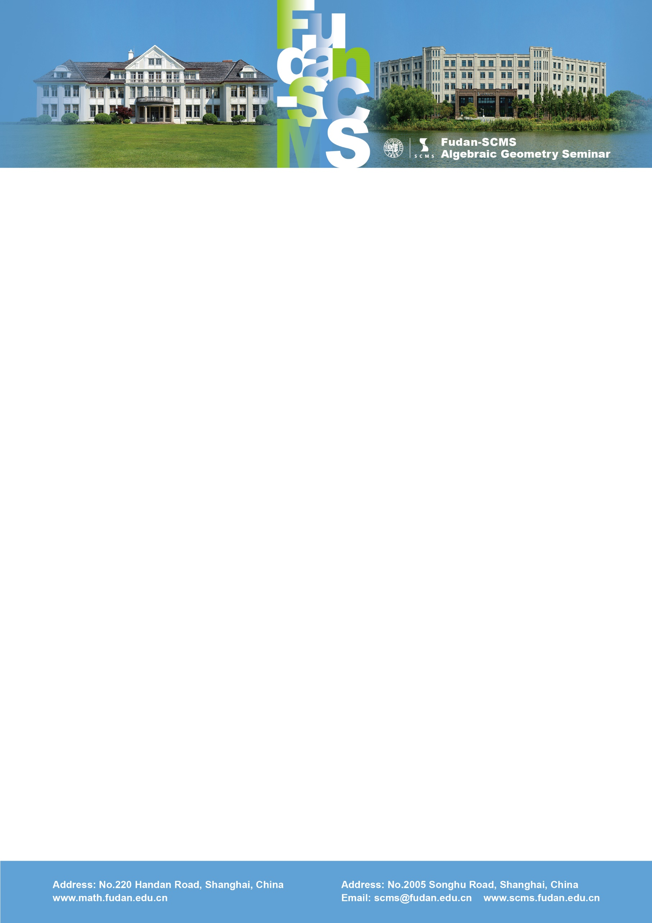

Fudan-SCMS Algebraic Geometry Seminar
Zoom Meeting Seminar
Lecture :
Some pathologies in birational geometry in positive characteristic
Speaker: Paolo Cascini (Imperial)
Time：Thu, July 2, BJS 16:00-17:00, EST 04:00-05:00, GMT 08:00-09:00
Zoom Meeting Id: 972 321 47595
Password: 535408
Abstract: Many results in the study of the birational geometry of complex varieties are expected to generalize to varieties defined over an algebraically closed field of arbitrary characteristic. On the other hand, mostly because of the failure of Bertini's theorem and Kodaira vanishing theorem in positive characteristic, this is not always the case. I will survey some recent results and counter-examples in this direction, focusing in particular, on the Iitaka conjecture.

