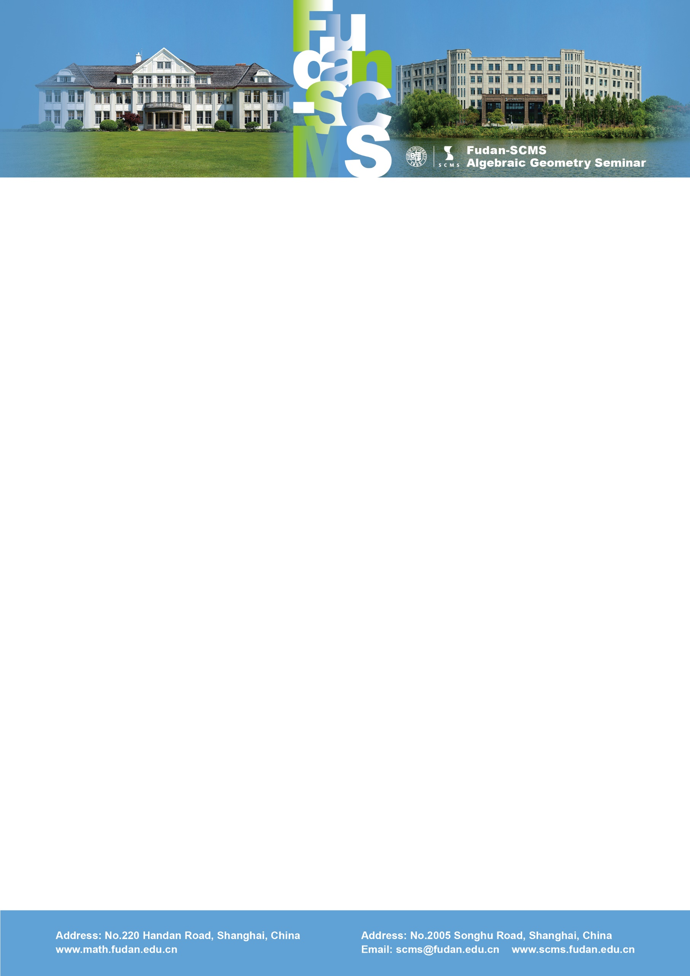

Fudan-SCMS Algebraic Geometry Seminar
Zoom Meeting Seminar
Lecture 1:
Rationality in families
Speaker: Brendan Hassett (Brown University)
New Time：Wed, June 11, BJS 20:00-21:00, EST 08:00-09:00, GMT 12:00-13:00
Zoom Meeting Id: 969 996 09294
Password: 360430
Lecture 1
Abstract: Consider a family of smooth complex projective varieties over a connected base. Which members are rational? Stably rational? We focus on recent general results and also outstanding questions that remain. These are illustrated in several key examples, including hypersurfaces of low degree. (joint with Kresch, Pirutka, and Tschinkel)

