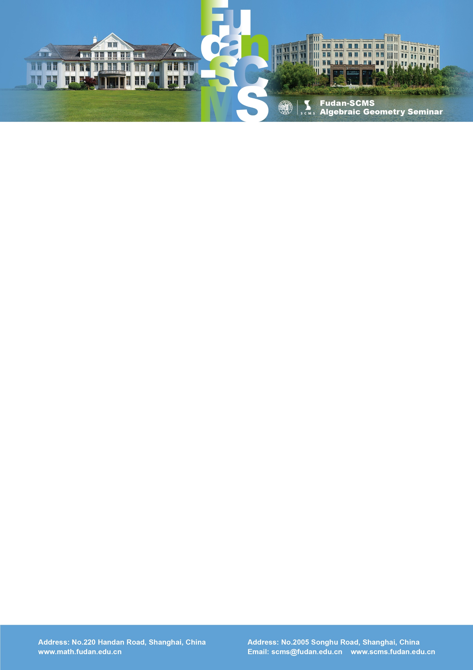

Fudan-SCMS Algebraic Geometry Seminar
Zoom Meeting Seminar
Lecture 1:
Descendents for stable pairs on 3-folds
Speaker: Rahul Pandharipande (ETH)
Time：Thu, May 14, BJS 20:00-21:00, EST 08:00-09:00, GMT 12:00-13:00
Lecture 2:
On the cohomology of the moduli of Higgs bundles
Speaker: Jun-Liang Shen (MIT)
Time: Thu, May 14, BJS 21:15-22:15, EST 09:15-10:15, GMT 13:15-14:15
Zoom Meeting Id: 969 894 11651
Password: 200430
Link: https: https://zoom.com.cn/j/96989411651
Lecture 1
Abstract: Descendent classes on moduli spaces of sheaves are defined via the Chern characters of the universal sheaf. I will present several conjectures and results concerning stable pairs descendent invariants for 3-folds: rationality of generating functions, functional equations, cobordism classes, and Virasoro constraints.
Lecture 2
Abstract: We will discuss cohomological structures of the moduli space of Higgs bundles associated with a curve. On one hand, the Higgs moduli space can be viewed as an enhancement of the moduli of vector bundles. They share a lot of common features in geometry and topology. On the other hand, the Higgs moduli space admits the structure of an algebraically integrable system, called the Hitchin fibration, whose fibers are global analogs of affine Springer fibers. Hence the cohomological study of Higgs moduli spaces have rich connections with orbital integrals (Ngô), mirrory symmetry (Hausel-Thaddeus), and non-abelian Hodge theory (de Cataldo-Hausel-Migliorini). We will discuss these connections and some recent progress. Based on joint work with Mark de Cataldo and Davesh Maulik.

