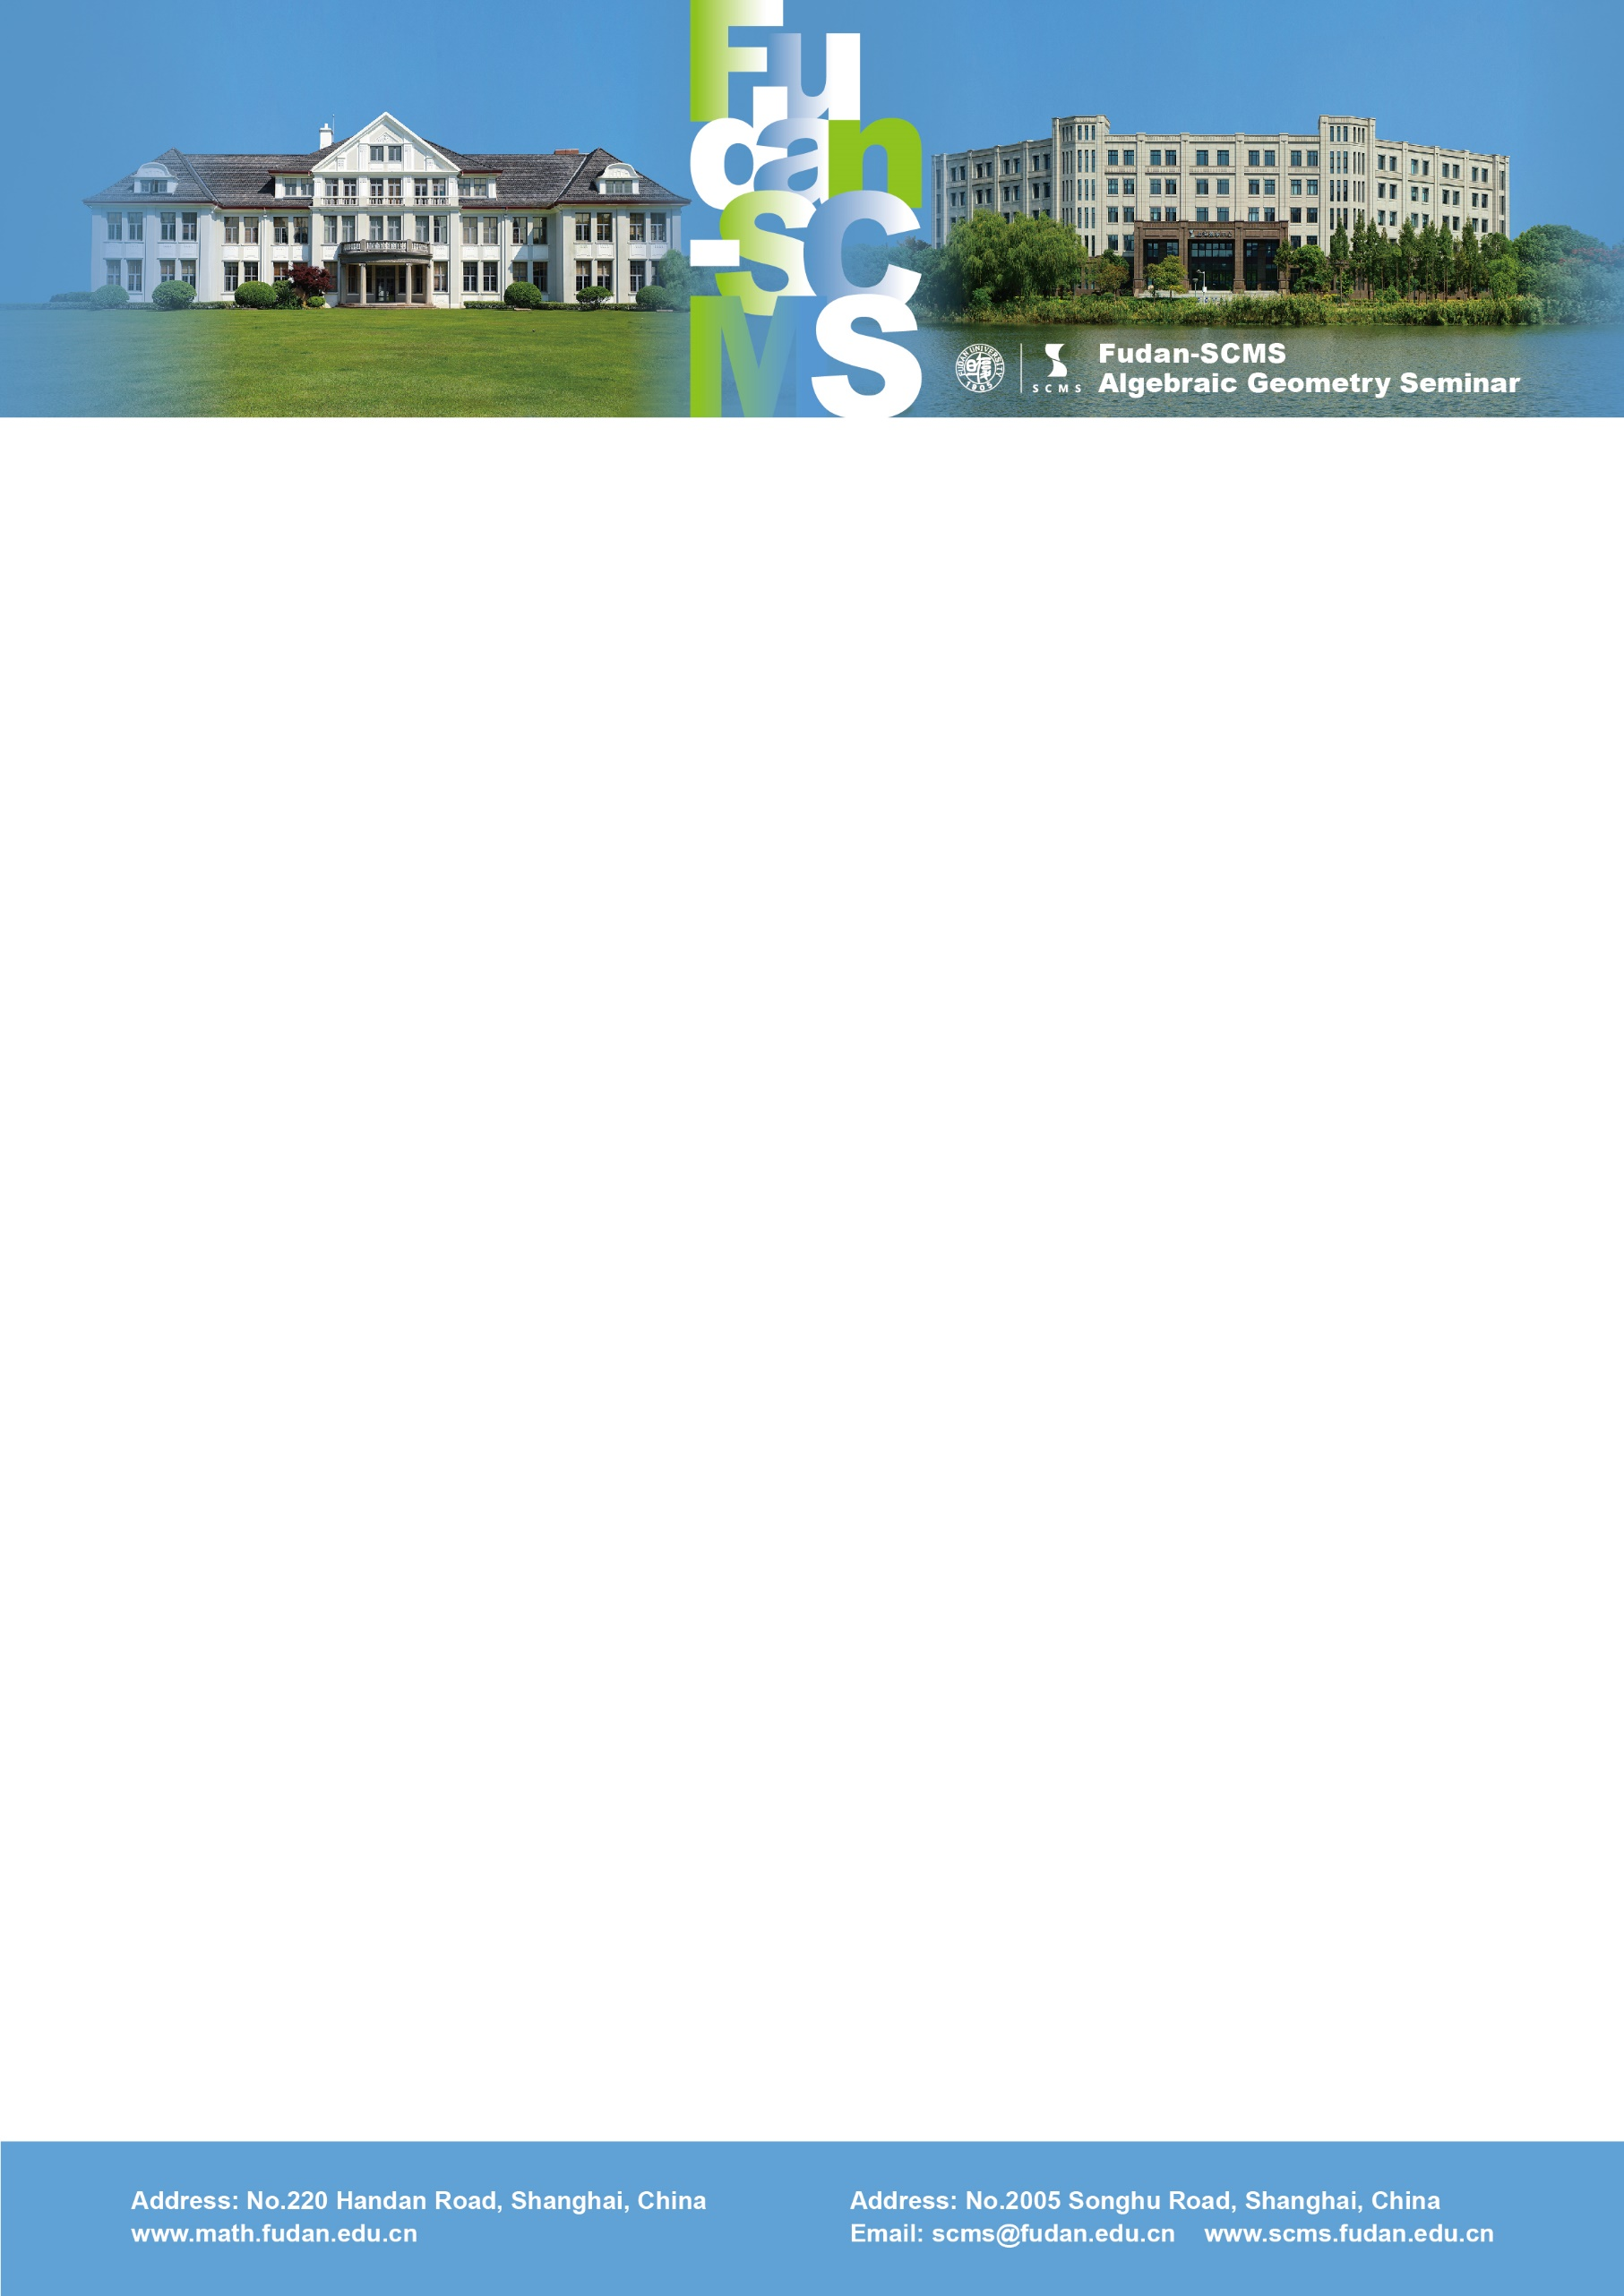

Fudan-SCMS Algebraic Geometry Seminar
Zoom Meeting Seminar
Lecture 1:
Stable rationality of complete intersections
Speaker: Johannes Nicaise (Imperial College/KU Leuven)
Time：Wed, June 17, BJS 16:30-17:30, EST 04:30-05:30, GMT 08:30-09:30
Zoom Meeting Id: 989 794 42473
Password: 126778
Lecture 1
Abstract: I will explain an ongoing project with John Christian Ottem to establish several new classes of stably irrational complete intersections. Our results are based on degeneration techniques and a birational version of the nearby cycles functor that was developed in collaboration with Evgeny Shinder.

