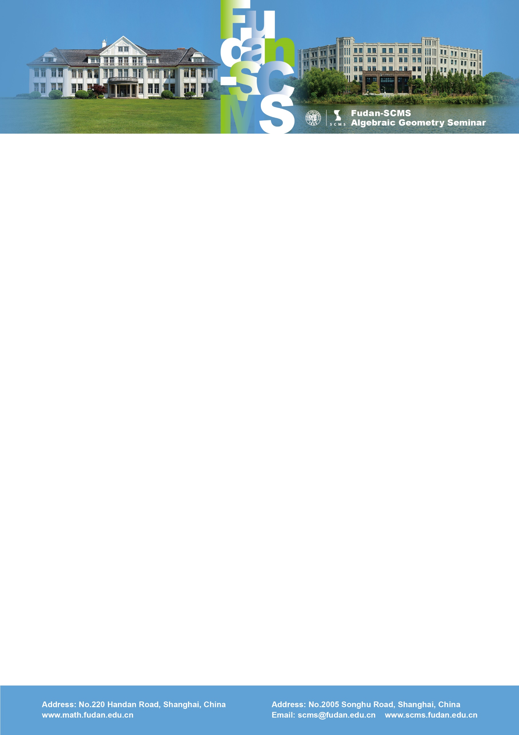

Fudan-SCMS Algebraic Geometry Seminar
Zoom Meeting Seminar
Lecture :
K-moduli of curves on a quadric surface and K3 surfaces
Speaker: Yuchen Liu (Yale)
Time：Thu, June 25, BJS 09:00-10:00, EST 21:00-22:00, GMT 01:00-02:00
Zoom Meeting Id: 938 176 04394
Password: 089746
Abstract: We show that the K-moduli spaces of log Fano pairs (P^1*P^1, cC) where C is a (4,4)-curve and their wall crossings coincide with the VGIT quotients of (2,4) complete intersection curves in P^3. This, together with recent results by Laza-O'Grady, implies that these K-moduli spaces form a natural interpolation between the GIT moduli space of (4,4)-curves on P^1*P^1 and the Baily-Borel compactification of moduli of quartic hyperelliptic K3 surfaces. Based on joint work with K. Ascher and K. DeVleming.

