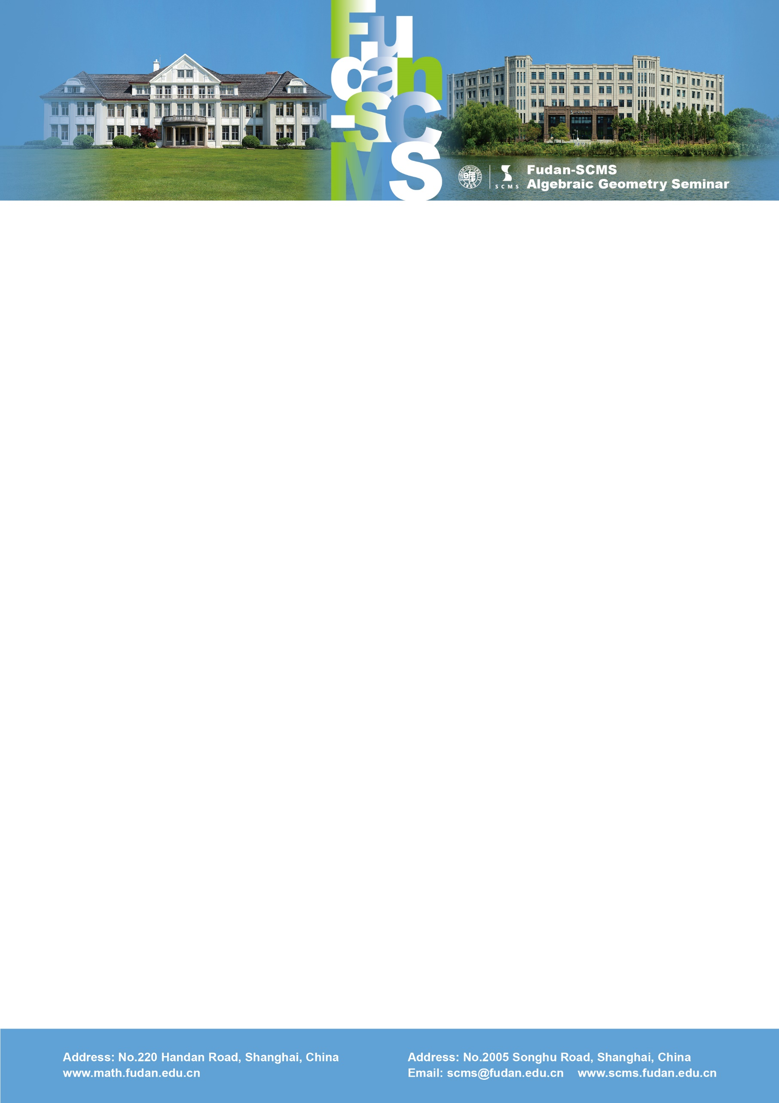

Fudan-SCMS Algebraic Geometry Seminar
Zoom Meeting Seminar
Lecture :
The Hodge conjecture for the generic abelian fourfold of Weil type with discriminant 1
Speaker: Eyal Markman (UMass)
Time：Thu, July 9, BJS 20:00-21:00, EST 08:00-09:00, GMT 12:00-13:00
Zoom Meeting Id: 948 415 75462
Password: 200433
Abstract: A generalized Kummer variety of dimension 2n is the fiber of the Albanese map from the Hilbert scheme of n+1 points on an abelian surface to the surface. We compute the monodromy group of a generalized Kummer variety via equivalences of derived categories of abelian surfaces.

